Lab03

Nguyen Nam Tung 103181157

**4-bit register**

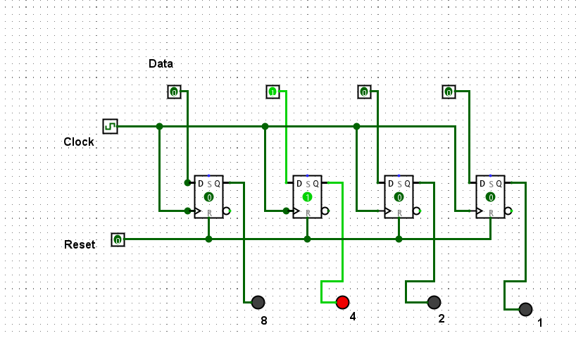

|  |  |  |
| --- | --- | --- |
| Ox | Input Binary | Output Binary |
| 0 | 0000 | 0000 |
| 1 | 0001 | 0001 |
| 2 | 0010 | 0010 |
| 3 | 0011 | 0011 |
| 4 | 0100 | 0100 |
| 5 | 0101 | 0101 |
| A | 1010 | 1010 |
| B | 1011 | 1011 |
| C | 1100 | 1100 |
| D | 1101 | 1101 |
| E | 1110 | 1110 |
| F | 1111 | 1111 |

**Name one crucial role (hardware) counters play in modern computing architectures**

Counters are used to store the count of activities in a computer

**Describe in a few sentences how a ripple counter works. How does the “ripple” occur?**

It is an asynchronous binary counter, which uses toggle FFs to put the output of one into another.

**Big-endian 3 ripples counter**

JK Flip Flop: Falling Edge => Count up

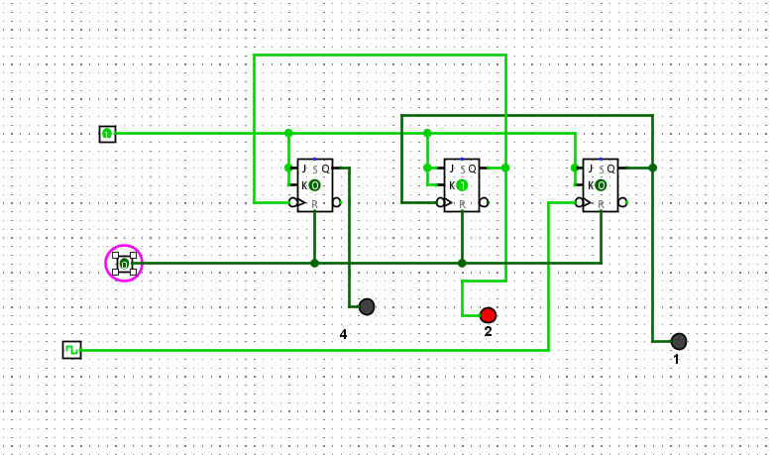

JK Flip Flop: Rising Edge: Count Down

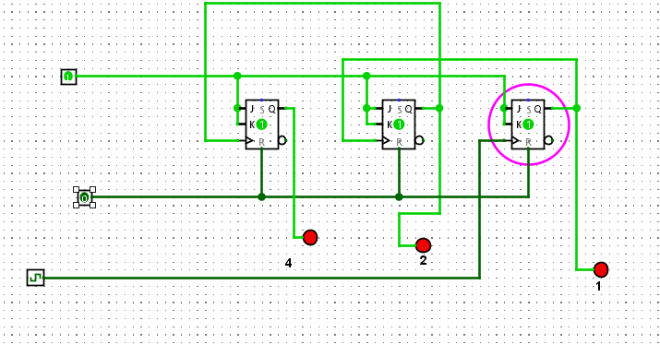

**Common Clock**

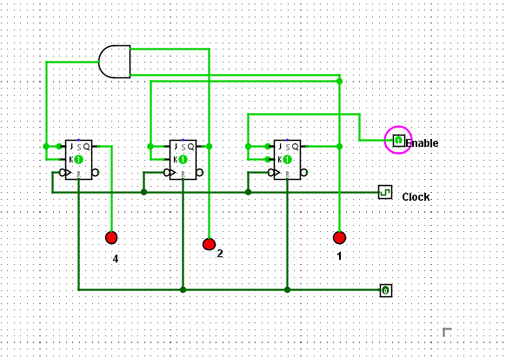

Count from 0 to 5 (Reset at 6)

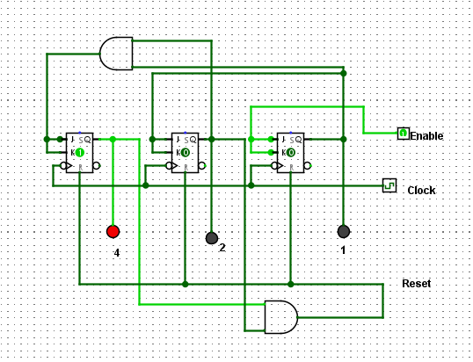

**Common Clock No illegal state with Hex Display (Circuit for step 17 + 18 combination)**

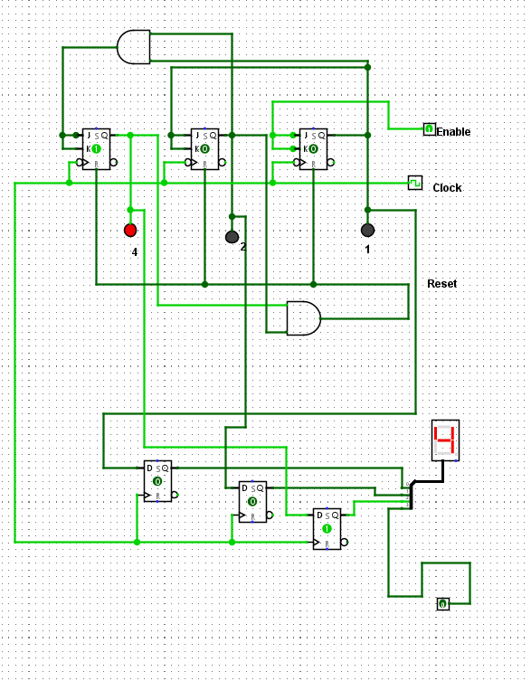

**Modify your counter so that it resets after 5 (101) back to 0 (000) without the momentary illegal state.**

Using D Flip Flop as a buffer (above image)

**Why is handling such things important?**

There will be no illegal state => Circuit can be stabilized